# File permissions in Linux

## Project description

The research team at my organization needs to update the permissions for some files and directories within their projects directory. The permissions do not currently show the principle of least privilege. Checking and updating the permissions will keep the files more secure.

## Check file and directory details

ls -la

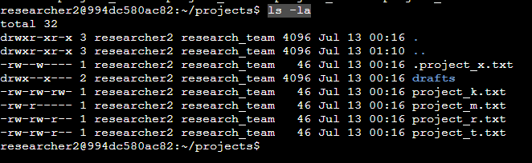

This screenshot shows how I used the ls -la command to review the permissions set. By using -la I was able to see there is a hidden file within the directory as well as 5 other files.

## Describe the permissions string

**drwxrwxrwx**

**-rwxrwxrwx**

d = Directory

- = File

r = Read

w = Write

x = Execute

**rwx rwx rwx**

**User | Group | Other**

## 

## 

## Change file permissions

chmod o-w project_k.txt

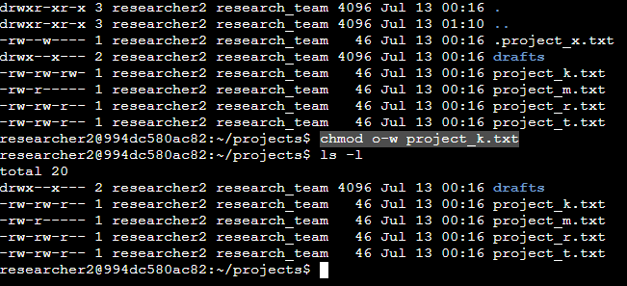

After reviewing the previous permissions I determined that project_k.txt needed the write option removed from other. The screenshot above shows how I used the chmod command to remove the permissions. I then used ls -l to verify the removal was successful.

## Change file permissions on a hidden file

chmod u=r,g=r .project_x.txt

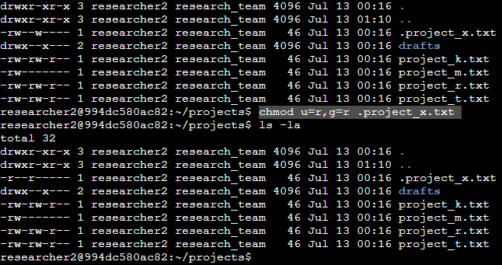

Starting off here I know that .project_x.txt is a hidden file because it starts with a period. In the example I set user and group permissions to only read. You can then see I used ls -la to review and verify the change was successful.

## Change directory permissions

chmod g-x drafts/

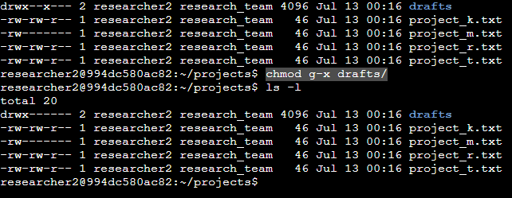

My organization only wanted the researcher2 user to have permissions to enter the draft directory. I used the chmod Linux command to remove execute permissions from group as they should not have these permissions. I then used ls -l to verify the permission changes were successful.

## Summary

I used Linux commands to change multiple permissions to match the authorization requested by my organization. The first step was to use ls -la to determine the current permissions. I then used the chmod command multiple times to add or remove permissions as requested. I also verified after every change that the commands were successful by using ls -la or ls-l.